**University of Michigan – Dearborn**

**CIS 150 – Computer Science 1**

**Lab# 5**

Quan Le

[lmmquan@umich.edu](mailto:lmmquan@umich.edu)

February 8, 2024

**Table Content**

Contents

Question 1 3

Test Cases 3

Source Code 3

Screenshots 3

Question 2 4

Test Cases 4

Source Code 5

Screenshots 5

Question 3 7

Test Cases 7

Source Code 8

Screenshots 8

# Question 1

## Test Cases

|  |  |  |  |  |  |
| --- | --- | --- | --- | --- | --- |
| Test # | Valid / Invalid Data | Description of test | Input Value | Actual Output | Test Pass / Fail |
| 1 | Valid | Input 2 positive values then quit. | input = 1  input = 2  input = 0 | The total is 3 | Pass |
| 2 | Valid | Input 3 negative values then quit | input = -2  input = -4  input = -6  input = 0 | The total is -12 | Pass |
| 3 | Valid | Quit immediately | input = 0 | The total is 0 | Pass |
| 4 | Valid | Input 1 positive value and 1 negative value, then quit | input = 100  input = -50  input = 0 | The total is 50 | Pass |

## Source Code

The source code for this question has been uploaded to Canvas as lab5q1.cpp.

## Screenshots

Test Case 1:

Test Case 2:

Test Case 3:

Test Case 4:

# Question 2

## Test Cases

|  |  |  |  |  |  |
| --- | --- | --- | --- | --- | --- |
| Test # | Valid / Invalid Data | Description of test | Input Value | Actual Output | Test Pass / Fail |
| 1 | Valid | Input 10 student grades of 75.00 | num = 10  grade = 75.00 | The calculated average grade is 75 | Pass |
| 2 | Valid | Input 1 student grade of 100.00 | num = 1  grade = 100.00 | The calculated average grade is 100 | Pass |
| 3 | Valid | Input 3 student grades of 98.75, 87.65 and 76.55 | num = 3  grade = 98.75  grade = 87.65  grade = 76.55 | The calculated average grade is 87.65 | Pass |
| 4 | Valid | Input 0 student | num = 0 | The calculated average grade is 0 | Pass |

## Source Code

The source code for this question has been uploaded to Canvas as lab5q2.cpp.

## Screenshots

Test Case 1:

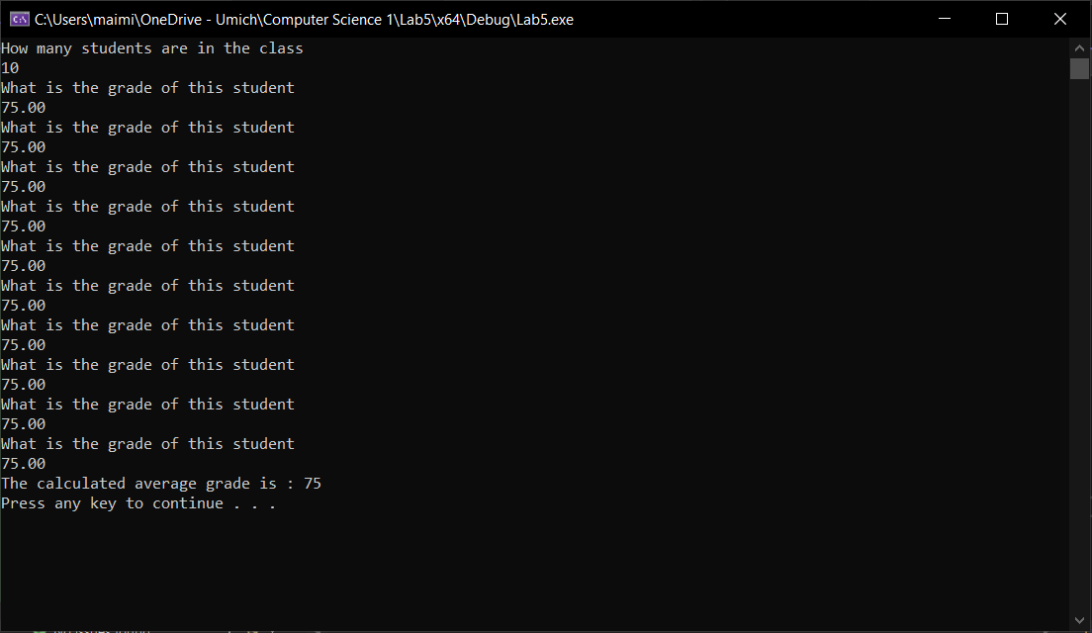

Test Case 2:

Test Case 3:

Test Case 4:

# Question 3

## Test Cases

|  |  |  |  |  |  |
| --- | --- | --- | --- | --- | --- |
| Test # | Valid / Invalid Data | Description of test | Input Value | Actual Output | Test Pass / Fail |
| 1 | Valid | Exit the program immediately | choice = 4 | Press any key to continue . . . | Pass |
| 2 | Valid | Input 2 integers, add the two values, multiply the two values and exit. | choice = 1  x = 5  y = -3  choice = 2  choice = 3  choice = 4 | The sum is: 2  The product is: -15  Press any key to continue . . . | Pass |
| 3 | Valid | Add two values, multiply two values and exit | choice = 2  choice = 3  choice = 4 | The sum is: 0  The product is: 0  Press any key to continue . . . | Pass |
| 4 | Valid | Enter an invalid choice, add the two values, and exit. | choice = 5  choice = 2  choice = 4 | Invalid choice  The sum is: 0  Press any key to continue . . . | Pass |

## Source Code

The source code for this question has been uploaded to Canvas as lab5q3.cpp.

## Screenshots

Test Case 1:

Test Case 2:

Test Case 3:

Test Case 4:

